**LAB#17**

**SPANNING TREE PROTOCOL**

# OBJECTIVE

To understand that how to avoid looping by using STP protocol.

**THEORY**

**SPANNING TREE PROTOCOL (STP)**

The Spanning Tree Protocol (STP) is a [link layer](http://en.wikipedia.org/wiki/Link_layer) [network protocol](http://en.wikipedia.org/wiki/Network_protocol) that ensures a loop-free [topology](http://en.wikipedia.org/wiki/Network_topology) for any [bridged](http://en.wikipedia.org/wiki/Bridging_(networking)) [LAN](http://en.wikipedia.org/wiki/Local_area_network). It is based on an [algorithm](http://en.wikipedia.org/wiki/Algorithm) invented by [Radia-Perlman](http://en.wikipedia.org/wiki/Radia_Perlman) while working for [Digital Equipment Corporation](http://en.wikipedia.org/wiki/Digital_Equipment_Corporation). In the [OSI model](http://en.wikipedia.org/wiki/OSI_model) for computer networking, STP falls under the [OSI layer-2](http://en.wikipedia.org/wiki/Data_link_layer). Spanning tree allows a network design to include spare (redundant) links to provide automatic backup paths if an active link fails, without the danger of bridge loops, or the need for manual enabling/disabling of these backup links. Bridge loops must be avoided because they result in flooding the network.

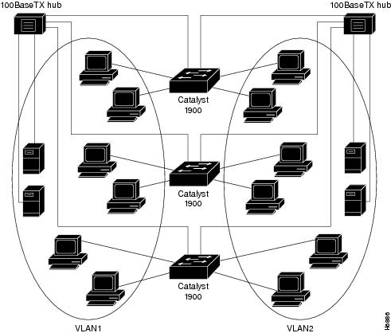

**Fig 13.1** Spanning Tree Protocol

**NETWORK SETUP:**



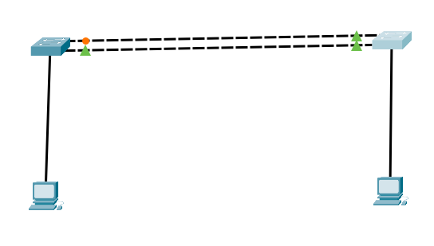

**CONFIGURATION:**

**STEP 1(a): Verifying Spanning Tree Protocol on 2950-SWA Switch**

**Switch#show spanning-tree**

VLAN0001

Spanning tree enabled protocol ieee

Root ID Priority 32769

Address 0030.A387.3147

This bridge is the root

Hello Time 2 sec Max Age 20 sec Forward Delay 15 sec

Bridge ID Priority 32769 (priority 32768 sys-id-ext 1)

Address 0030.A387.3147

Hello Time 2 sec Max Age 20 sec Forward Delay 15 sec

Aging Time 20

Interface Role Sts Cost Prio.Nbr Type

---------------- ---- --- --------- -------- --------------------------------

Fa0/23 Desg FWD 19 128.23 P2p

Fa0/24 Desg FWD 19 128.24 P2p

**STEP 1(b): Verifying the detail information of Spanning Tree Protocol on 2950-SWA Switch**

**Switch#show spanning-tree detail**

VLAN0001 is executing the ieee compatible Spanning Tree Protocol

Bridge Identifier has priority of 32768, sysid 1, 0030.A387.3147

Configured hello time 2, max age 20, forward delay 15

We are the root of the spanning tree

Topology change flag not set, detected flag not set

Number of topology changes 0 last change occurred 00:00:00 ago

from FastEthernet0/1

Times: hold 1, topology change 35, notification 2

hello 2, max age 20, forward delay 15

Timers: hello 0, topology change 0, notification 0, aging 300

Port 23 (FastEthernet0/23) of VLAN0001 is designated forwarding

Port path cost 19, Port priority 128, Port Identifier 128.23

Designated root has priority 32769, address 0030.A387.3147

Designated bridge has priority 32769, address 0030.A387.3147

Designated port id is 128.23, designated path cost 19

Timers: message age 16, forward delay 0, hold 0

Number of transitions to forwarding state: 1

Link type is point-to-point by default

Port 24 (FastEthernet0/24) of VLAN0001 is designated forwarding

Port path cost 19, Port priority 128, Port Identifier 128.24

Designated root has priority 32769, address 0030.A387.3147

Designated bridge has priority 32769, address 0030.A387.3147

Designated port id is 128.24, designated path cost 19

Timers: message age 16, forward delay 0, hold 0

Number of transitions to forwarding state: 1

Link type is point-to-point by default

**STEP 2(a): Verifying the Spanning Tree Protocol on 2950-SWB Switch**

**Switch#show spanning-tree**

VLAN0001

Spanning tree enabled protocol ieee

Root ID Priority 32769

Address 0030.A387.3147

Cost 19

Port 23(FastEthernet0/23)

Hello Time 2 sec Max Age 20 sec Forward Delay 15 sec

Bridge ID Priority 32769 (priority 32768 sys-id-ext 1)

Address 00E0.B0E9.75EE

Hello Time 2 sec Max Age 20 sec Forward Delay 15 sec

Aging Time 20

Interface Role Sts Cost Prio.Nbr Type

---------------- ---- --- --------- -------- --------------------------------

Fa0/24 Altn BLK 19 128.24 P2p

Fa0/23 Root FWD 19 128.23 P2p

**STEP 2(b): Verifying the detail information of Spanning Tree Protocol on 2950-SWB Switch**

**Switch#show spanning-tree detail**

VLAN0001 is executing the ieee compatible Spanning Tree Protocol

Bridge Identifier has priority of 32768, sysid 1, 00E0.B0E9.75EE

Configured hello time 2, max age 20, forward delay 15

Current root has priority 32769

Root port is 23 (FastEthernet0/23), cost of root path is 19

Topology change flag not set, detected flag not set

Number of topology changes 0 last change occurred 00:00:00 ago

from FastEthernet0/1

Times: hold 1, topology change 35, notification 2

hello 2, max age 20, forward delay 15

Timers: hello 0, topology change 0, notification 0, aging 300

Port 23 (FastEthernet0/23) of VLAN0001 is root forwarding

Port path cost 19, Port priority 128, Port Identifier 128.23

Designated root has priority 32769, address 0030.A387.3147

Designated bridge has priority 32769, address 0030.A387.3147

Timers: message age 16, forward delay 0, hold 0

Number of transitions to forwarding state: 1

Link type is point-to-point by default

Port 24 (FastEthernet0/24) of VLAN0001 is alternate blocking

Port path cost 19, Port priority 128, Port Identifier 128.24

Designated root has priority 32769, address 0030.A387.3147

Designated bridge has priority 32769, address 0030.A387.3147

Timers: message age 16, forward delay 0, hold 0

Number of transitions to forwarding state: 1

Link type is point-to-point by default

**STEP 3: Changing non root to root Switch by decreasing the priority on 2950-SWB (Non Root Switch)**

Switch(config)#spanning-tree vlan 1 priority 4096

**STEP 4(a): Verifying the Spanning Tree Protocol on 2950-SWB Switch after changing priority on 2950-SWB**

**Switch#show spanning-tree**

VLAN0001

Spanning tree enabled protocol ieee

Root ID Priority 4097

Address 00E0.B0E9.75EE

This bridge is the root

Hello Time 2 sec Max Age 20 sec Forward Delay 15 sec

Bridge ID Priority 4097 (priority 4096 sys-id-ext 1)

Address 00E0.B0E9.75EE

Hello Time 2 sec Max Age 20 sec Forward Delay 15 sec

Aging Time 20

Interface Role Sts Cost Prio.Nbr Type

---------------- ---- --- --------- -------- --------------------------------

Fa0/24 Desg FWD 19 128.24 P2p

Fa0/23 Desg FWD 19 128.23 P2p

**STEP 4(b): Verifying the Spanning Tree Protocol on 2950-SWB Switch after changing priority on 2950-SWB**

**Switch#show spanning-tree**

VLAN0001

Spanning tree enabled protocol ieee

Root ID Priority 4097

Address 00E0.B0E9.75EE

Cost 19

Port 23(FastEthernet0/23)

Hello Time 2 sec Max Age 20 sec Forward Delay 15 sec

Bridge ID Priority 32769 (priority 32768 sys-id-ext 1)

Address 0030.A387.3147

Hello Time 2 sec Max Age 20 sec Forward Delay 15 sec

Aging Time 20

Interface Role Sts Cost Prio.Nbr Type

---------------- ---- --- --------- -------- --------------------------------

Fa0/23 Root FWD 19 128.23 P2p

Fa0/24 Altn BLK 19 128.24 P2p

**STEP 5: Select Port on (Non-Root Switch by Changing Cost of Port on 2950-SWA)**

Switch(config)#int fa 0/24

Switch(config-if)#spanning-tree vlan 1 cost 18

**STEP 6: Verifying the Spanning Tree Protocol on 2950-SWA Switch after changing Cost of Port**

**Switch#sh spanning-tree**

VLAN0001

Spanning tree enabled protocol ieee

Root ID Priority 4097

Address 00E0.B0E9.75EE

Cost 18

Port 24(FastEthernet0/24)

Hello Time 2 sec Max Age 20 sec Forward Delay 15 sec

Bridge ID Priority 32769 (priority 32768 sys-id-ext 1)

Address 0030.A387.3147

Hello Time 2 sec Max Age 20 sec Forward Delay 15 sec

Aging Time 20

Interface Role Sts Cost Prio.Nbr Type

---------------- ---- --- --------- -------- --------------------------------

Fa0/23 Altn BLK 19 128.23 P2p

Fa0/24 Root FWD 18 128.24 P2p

**STEP 6: Verifying the Spanning Tree Protocol on 2950-SWB Switch after changing Cost of Port**

**Switch#sh spanning-tree vlan 1**

VLAN0001

Spanning tree enabled protocol ieee

Root ID Priority 4097

Address 00E0.B0E9.75EE

This bridge is the root

Hello Time 2 sec Max Age 20 sec Forward Delay 15 sec

Bridge ID Priority 4097 (priority 4096 sys-id-ext 1)

Address 00E0.B0E9.75EE

Hello Time 2 sec Max Age 20 sec Forward Delay 15 sec

Aging Time 20

Interface Role Sts Cost Prio.Nbr Type

---------------- ---- --- --------- -------- --------------------------------

Fa0/24 Desg FWD 19 128.24 P2p

Fa0/23 Desg FWD 19 128.23 P2p

## **LAB ASSIGNMENT**

Q1.Attach Lab task of the class.

## **HOME ASSIGNMENT**

Q1: What are the advantages of STP?

Q2: How STP Works?

Q3:Why we change the cost on switch ?